**Xi Jinping draws a roadmap for the development of media integration**

Source: CCTV News Client

Editor: Wang Bo

2019-01-28

<https://politics.rmlt.com.cn/2019/0128/538312.shtml>

On January 25, the Political Bureau of the CPC Central Committee held its 12th collective study session, with the theme of the all-media era and media convergence development. The location of this collective study session was somewhat special, as the "classroom" was moved to the front line of media convergence development.

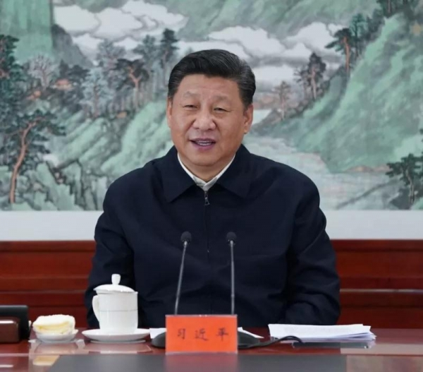

△On January 25, 2019, the Political Bureau of the CPC Central Committee held its twelfth collective study session at the People's Daily on the all-media era and media integration development. Xi Jinping, General Secretary of the CPC Central Committee, presided over the study session and delivered an important speech.

"The key to integrated development is integration and unity." Since the 18th CPC National Congress, the CPC Central Committee with Comrade Xi Jinping as the core has attached great importance to the integrated development of traditional media and emerging media. From proposing "the major task of promoting the integrated development of media" to "promoting the in-depth development of media integration", from strengthening top-level design to proposing the reengineering of the editing and publishing process and the construction of integrated media centers, Xi Jinping's important expositions have drawn a roadmap for the integrated development of media.

**Multiple inspections: Experience new media products and focus on integrated development**

On December 25, 2015, Xi Jinping visited the PLA Daily and posted a microblog on the PLA Daily's Weibo and WeChat publishing platforms, sparking heated discussions among netizens. Not only did he post a microblog himself, Xi Jinping also visited the PLA Daily's online publicity center, watched the reporter team's "Spring Festival Visit to the Grassroots" themed interview activity through the video system, inspected the rapid publishing system, and learned about the PLA Daily's media integration development.

On the morning of February 19, 2016, Xi Jinping visited three central news organizations, namely People's Daily, Xinhua News Agency and China Central Television, for research. At People's Daily, Xi Jinping walked into the new media center and sat down in front of a computer, sending a voice message through the new media platform to extend his greetings and blessings for the Lantern Festival to the people of the country; at Xinhua News Agency, Xi Jinping watched the display of news information products such as the Xinhua Silk Road Database and the China Photo Archives Data Management System, and then clicked on the screen of his mobile phone to give thumbs up to journalists across the country through the Xinhua News Agency client; at China Central Television, Xi Jinping listened to the introduction of China Central Television's business and media integration, and personally switched buttons in the studio of "News Broadcast" to experience the simulated broadcast.



On January 25, 2019, the Political Bureau of the CPC Central Committee held its 12th collective study session at the People's Daily on the all-media era and media integration development. This was **the second time that the Political Bureau of the CPC Central Committee had held a collective study session outside Zhongnanhai since the 18th CPC** National Congress. Xi Jinping and others came to the People's Daily and learned about the People's Daily's efforts to integrate various resources such as newspapers, websites, terminals, microblogs, and screens to achieve all-media communication, based on a video clip.

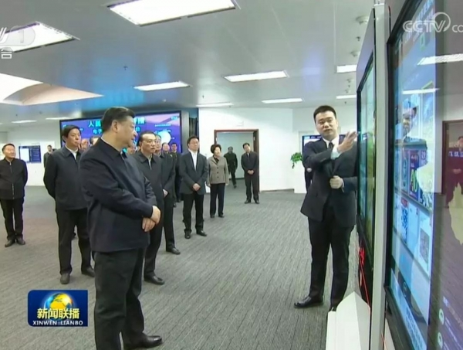

**A judgment: It is urgent to promote the development of media integration and build an all-media**

Why does Xi Jinping attach so much importance to the development of media integration? With the development of technology, the media landscape, public opinion ecology, audiences, and communication technologies are undergoing profound changes. In particular, the Internet is stimulating an unprecedented transformation in the media field. In today's society, omnimedia is constantly developing, and full-process media, holographic media, full-staff media, and full-effect media have emerged. Information is everywhere, all-encompassing, and everyone uses it. News and public opinion work faces new challenges. Xi Jinping believes that promoting the development of media integration and building omnimedia has become an urgent issue we face.

**One major goal: to build several powerful new media groups**

In the face of new changes, what should mainstream media do? This is a question that Xi Jinping has been concerned about and thinking about for a long time. At the National Conference on Propaganda and Ideology held on August 19, 2013, Xi Jinping pointed out sharply that many people, especially young people, basically do not watch mainstream media, and most of their information is obtained from the Internet. We must face up to this fact, increase our efforts, and **seize the initiative in this public opinion battlefield as soon as possible. We must not be marginalized** , solve the problem of "skill panic", and truly become experts in using new means and methods of modern media.

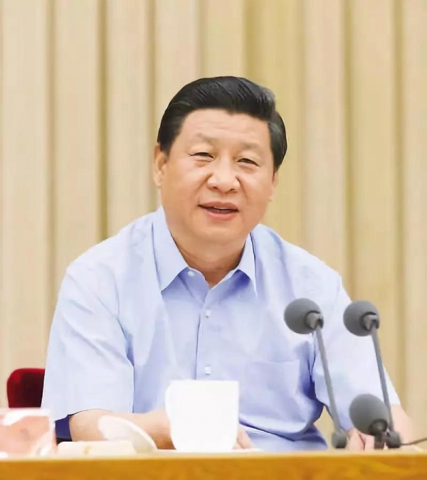

△On August 19, 2013, Xi Jinping delivered a speech at the National Propaganda and Ideological Work Conference

On August 18, 2014, the 4th meeting of the 18th Central Leading Group for Comprehensively Deepening Reforms reviewed and approved the "Guiding Opinions on Promoting the Convergence of Traditional and New Media", which issued a top-level design for the development of media convergence. Xi Jinping stressed that **efforts should be made to build a number of new mainstream media with diverse forms, advanced means and competitiveness, to build several new media groups with strong strength, communication power, credibility and influence, and to form a three-dimensional, diverse and integrated modern communication system.**

On February 19, 2016, at the symposium on news and public opinion work of the Party, Xi Jinping pointed out that it is necessary to move from the "addition" stage to the "integration" stage as soon as possible, from "you are you and I am me" to "you are in me and I am in you", and then to "you are me and I am you", and strive to create a batch of new mainstream media.

**Guiding ideology: Follow the laws of development and strengthen Internet thinking**

The goal has been set, how to achieve it? Xi Jinping stressed at the fourth meeting of the 18th Central Leading Group for Comprehensively Deepening Reform that in promoting the integrated development of traditional media and emerging media, we must follow the laws of news dissemination and the laws of emerging media development, strengthen Internet thinking, and adhere to the complementary advantages and integrated development of traditional media and emerging media.

On December 25, 2015, when inspecting the People's Liberation Army Daily, Xi Jinping emphasized the need to study and grasp the laws of modern news dissemination and the development of emerging media, strengthen Internet thinking and the concept of integrated development, promote the effective integration of various media resources and production factors, and promote the sharing and integration of information content, technological applications, platform terminals, and talent teams.

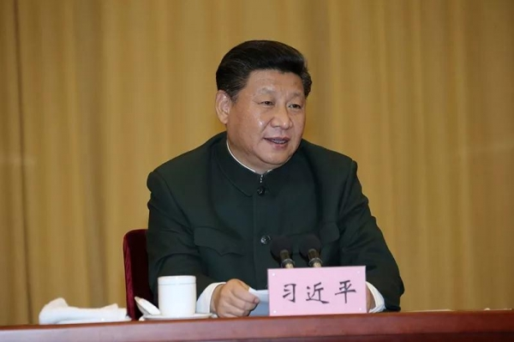

△On December 25, 2015, Xi Jinping visited the People's Liberation Army Daily and delivered an important speech

**Method and path: technical support content-oriented, seize opportunities and innovate means**

In terms of the path to implementation, Xi Jinping's series of important statements also pointed out the direction for the development of media integration.

At the fourth meeting of the 18th Central Leading Group for Comprehensively Deepening Reforms, Xi Jinping emphasized the need to adhere to **advanced technology as the support and content construction as the foundation, and to promote the deep integration of traditional media and new media in terms of content, channels, platforms, operations, and management.**

On February 19, 2016, at the forum on news and public opinion work of the Party, Xi Jinping pointed out that we should adapt to the trend of segmented and differentiated communication and accelerate the construction of a new pattern of public opinion guidance. We should promote integrated development and take the initiative to make use of the advantages of new media communication.

On August 21, 2018, Xi Jinping stressed at the National Conference on Propaganda and Ideological Work that we must strengthen the innovation of communication methods and discourse methods to make the Party's innovative theories "reach the homes of ordinary people". We must do a solid job in the construction of county-level integrated media centers to better guide and serve the people.

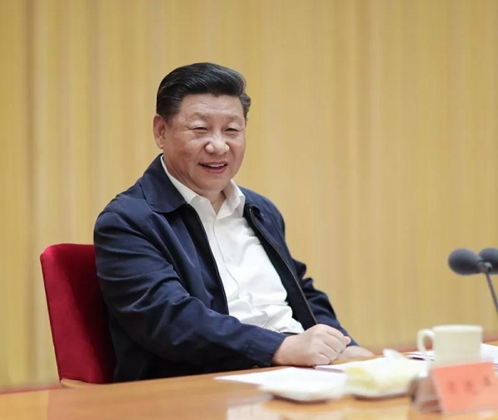

△At the 2018 National Propaganda and Ideological Work Conference, Xi Jinping attended the meeting and delivered an important speech

During this collective study session of the Political Bureau, Xi Jinping emphasized the need to strengthen the construction and innovation of communication means, develop various new media such as websites, Weibo, WeChat, electronic newsstands, mobile newspapers, and online TV, and actively develop various interactive, service-oriented, and experiential news information services to achieve all-round coverage, all-weather extension, and multi-field expansion of news dissemination, promote the party's voice to directly enter various user terminals, and strive to occupy new public opinion fields.

He also stressed the need to promote the development of media integration:

**We must adhere to the direction of integrated development** , and through process optimization and platform reconstruction, achieve effective integration of various media resources and production factors, realize the integration and interconnection of information content, technological applications, platform terminals, and management methods, catalyze qualitative changes in integration, amplify integrated efficiency, and create a group of new mainstream media with strong influence and competitiveness.

**We must adhere to the mobile-first strategy** and allow mainstream media to use mobile communications to firmly occupy the commanding heights of communication **in guiding public opinion, leading thoughts, inheriting culture, and serving the people** .

**We should explore the application of artificial intelligence in news collection, production, distribution, reception and feedback** , and comprehensively improve our ability to guide public opinion.

**It is necessary to coordinate the relationship between traditional media and emerging media, central media and local media, mainstream media and commercial platforms, popular media and professional media** , and form an all-media communication system that is resource-intensive, structurally reasonable, differentiated in development, and coordinated and efficient.

**We must strengthen the management of emerging media in accordance with the law** to make our cyberspace clearer.

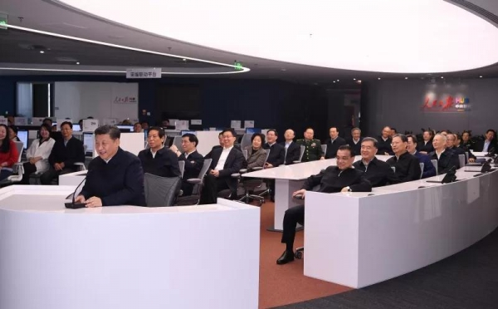

△Xi Jinping communicated with reporters and the first secretary of the poverty alleviation village in Yuying Village, Pingfang Manchu Township, Luanping County, Chengde City, Hebei Province, at the People's Daily to learn about the progress of the village's poverty alleviation work

Where the readers are, where the audience is, where the tentacles of propaganda and reporting should be extended, and where the focus and foothold of propaganda and ideological work should be placed. In the face of profound changes in the pattern of public opinion dissemination brought about by new technologies, it is necessary to accelerate the development of media integration, so that mainstream media have strong dissemination, guidance, influence, and credibility, forming concentric circles online and offline, so that all people can be closely united in ideals, beliefs, values, and moral concepts, so that positive energy can be stronger and the main theme can be more uplifting. Xi Jinping's important expositions have drawn a roadmap for the development of media integration from many aspects such as development goals, guiding ideology, and implementation paths.